# **System Use Case Specifications - addCourse()**

## **Add new Course to Program/Database**

### **Author: Khai Phan**

### **Short Description of the System Use Case**

* Adding a new course to the program category, each course can only belong to a program

### **Actor(s)**

* System Administrator
* Database

### **System Use Case Preconditions**

* The new course must not already exist in the system
* The course must satisfy all requirement (dates, description, course code, program inherited)

### **System Use Case Successful Post Conditions**

* Successfully added a new course

### **Applicable Business Rules**



### **Main Flow:**

|  |  |  |
| --- | --- | --- |
|  | **Actor (System Administrator)** | **System** |
| 1 | Request to add new a course | Return program list |
| 2 | Select the program | Required course details and information |
| 3 | Enter the required information | Validate information (1), display course added successfully |

### **Alternate Flows**

|  |  |  |
| --- | --- | --- |
|  | Alternate Flow | Description |
| A1 | Same course name/course code | If there is already an existing program with a matching name/course code, the system requires the user to enter a different one |

### 

# **System Use Case Specifications - removeCourse()**

## **Remove existing course from Program/Database**

### **Author: Adrian Recchi**

### **Short Description of the System Use Case**



### **Actor(s)**

* System Administrator
* Database

### **System Use Case Preconditions**

* Course must already exist within the system

### **System Use Case Successful Post Conditions**

* Successfully able to remove a course

### **Applicable Business Rules**

* Removing a course should be simple and convenient for the user

### **Main Flow:**

|  |  |  |
| --- | --- | --- |
|  | **Actor (Administrator)** | **System** |
| 1 | Enters course code | Displays course information |
| 2 | Requests to remove course | Requests password for verification |
| 3 | Inputs password | Course is marked as inactive |
| 4 |  |  |
| 5 |  |  |

### **Alternate Flows**

|  |  |  |
| --- | --- | --- |
|  | **Actor (Administrator)** | **System** |
| A1 | Enters course code | Displays course information |
| A2 | Requests to remove course | Course cannot be removed due to current registrations |
| A3 | Enters another course | Displays course information |
| A4 | Requests to remove course | Requests password for verification |
| A5 | Inputs password | Incorrect password |
| A6 | Inputs again (gets 3 tries) | Locks user out after 3 failed attempts |
|  |  |  |

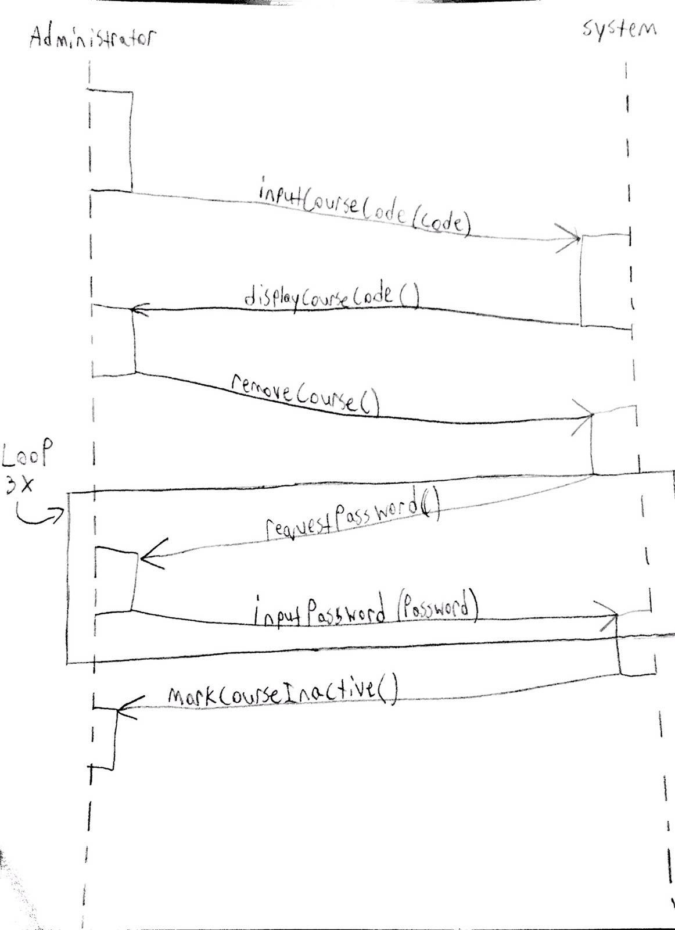

# **System Use Case Specifications - updateCourse()**

## **Update course in the program/database**

### **Author: Luqman Dewji**

### **Short Description of the System Use Case**

* updating only a course description from a list of displayed courses using a specific program, all course details are displayed.

### **Actor(s)**

* System Administrator(secondary actor)
* Database (primary actor)

### **System Use Case Preconditions**

* The course and its details should already exist in the system.
* A course needs an update.

### **System Use Case Successful Post Conditions**

* Updated course description.
* No more updates are required for courses.

### **Applicable Business Rules**

* Easy to update the course description.

### **Main Flow:**

|  |  |  |
| --- | --- | --- |
|  | **Actor (System Administrator)** | **System** |
| 1 | Request to update course | Display list of courses |
| 2 | Select course for update | Display course details |
| 3 | Change course description and request to save | Validate update and save changes |
| 4 |  |  |
| 5 |  |  |

### **Alternate Flows**

|  |  |  |
| --- | --- | --- |
|  | Alternate Flow | Description |
| A1 | Illegal characters in course description | A message is given and asked to fix errors or cancel |
| A2 |  |  |
| A3 |  |  |

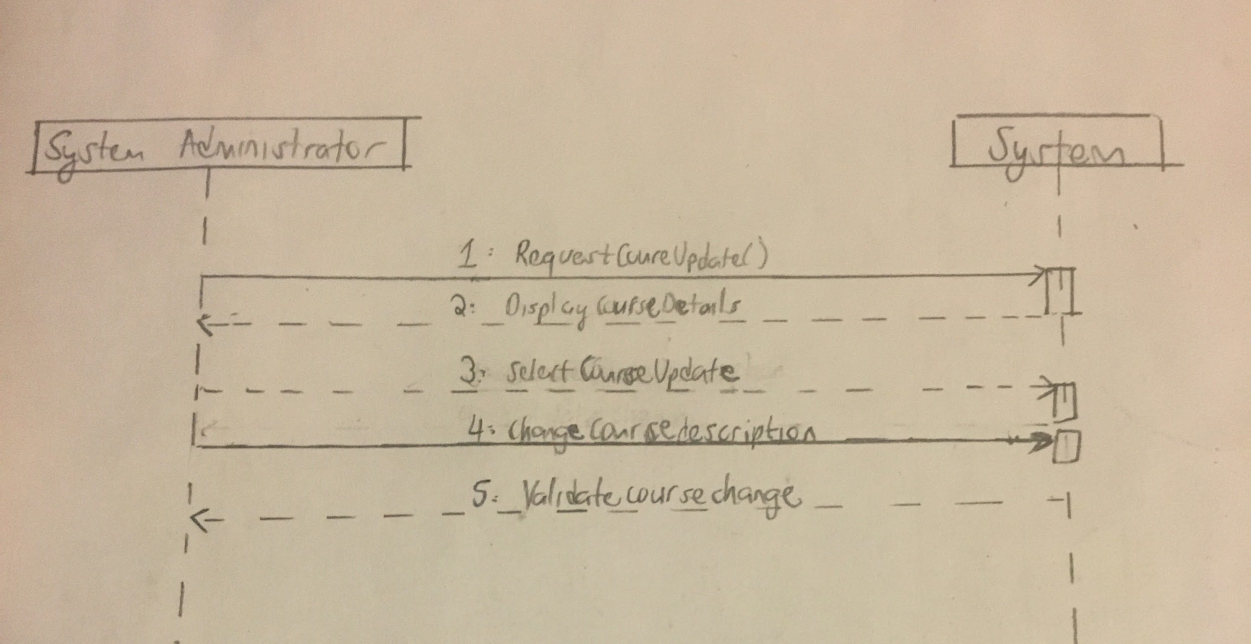

# 

# 

# 

# **System Use Case Specifications - addHeadInstructorToCourse()**

## 

### **Author: Zain Ali**

### **Short Description of the System Use Case**

* Add Instructor to Course

### **Actor(s)**

* System Administrator
* Database

### **System Use Case Preconditions**

* Only Active Instructors can be added to courses
* Courses must be active for an instructor to be added

### **System Use Case Successful Post Conditions**

* Successfully added a instructor to a course

### **Applicable Business Rules**



### **Main Flow:**

|  |  |  |
| --- | --- | --- |
|  | **Actor (Administrator)** | **System** |
| 1 | Requests to add head instructor to course | list of programs is displayed |
| 2 | selects program | list of active courses that do not have a head instructor displayed |
| 3 | selects one of the displayed courses | course information displayed along with active instructors |
| 4 | selects one of the instructors to add as head | requests confirmation |
| 5 | confirms | updated course showing the added head instructor is displayed |

### **Alternate Flows**

|  |  |  |
| --- | --- | --- |
|  | **Actor(aDMINISTRATOR)** | **System** |
| A1 | Cancels upon confirmation | list of instructors is displayed again |
| A2 | can choose another instructor or leave program |  |
| A3 |  |  |

